Timothy Horrell

ECE 1770

Homework 2

1a)

1b)



2a)

2b)

\*\*I believe it represents the same way as zeros aren’t included in CSR form anyway.

3)

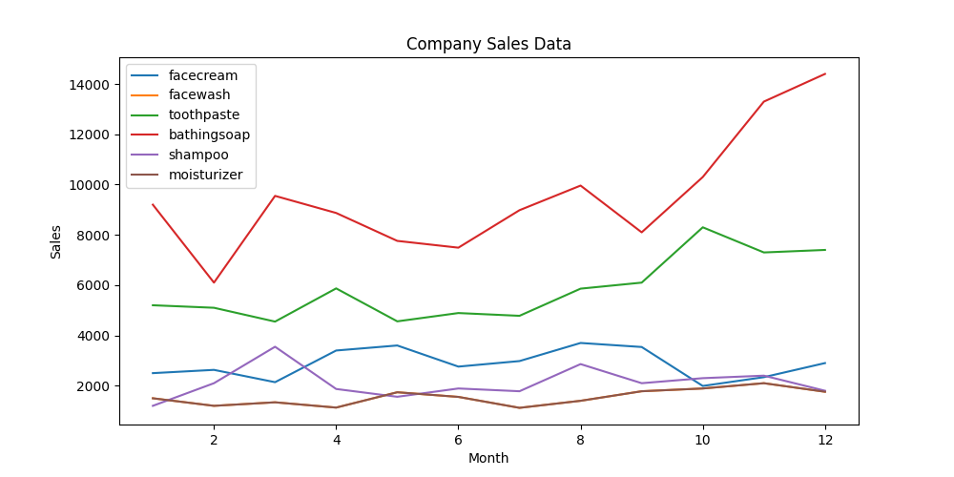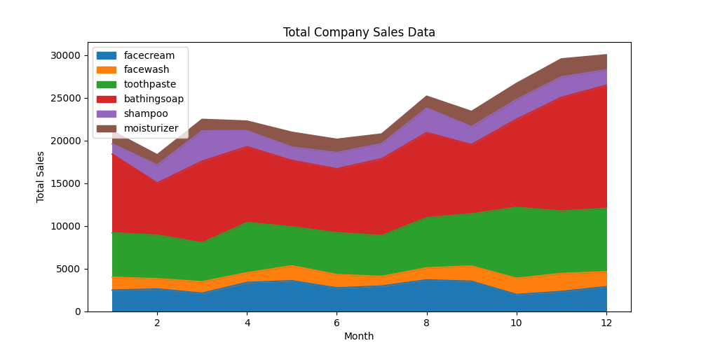

4a)

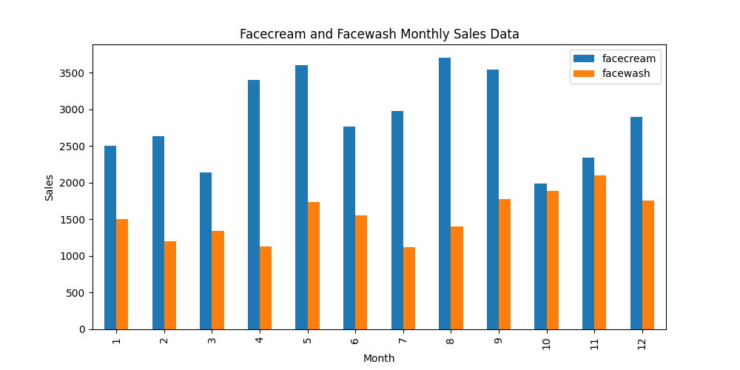

4b)

5a)

5b)

